------------------------------------------------------------------------------------------------
Smart Water Management
------------------------------------------------------------------------------------------------

Project Name :

- Smart Water Management

Project Description:

The project aims to implement IoT sensors in public places such as parks and gardens to monitor water consumption in real-time. The main objective is to promote water conservation by making the water consumption data publicly available. The project involves several key components, including:
- Defining Objectives: Clearly identifying the goals and objectives of the project, which in this case is to monitor water consumption and promote water conservation in public places.
- Designing the IoT Sensor System: Developing a system that includes IoT sensors capable of measuring water consumption accurately. These sensors will be installed in parks and gardens to monitor water usage in real-time.
- Developing the Data-Sharing Platform: Creating a platform where the collected data from the IoT sensors can be stored and accessed. This platform will provide real-time information on water consumption to the public.
- Integrating IoT Technology and Python: Utilizing IoT technology to connect the sensors and gather data, and using Python programming language to process and analyze the collected data. Python can be used for data visualization, data analysis, and developing the data-sharing platform.
By implementing this project, the public will have access to real-time water consumption data, which can raise awareness about water usage and promote water conservation efforts in public places.
Design Thinking:
- Soil moister sensors .
- environmental sensor ,

- DIGITEN G1/2 Water Flow Hall Sensor Switch Flow Meter Flowmeter Counter
Environmental sensor :
This module uses an environmental sensor manufactured by Bosch with temperature, barometric pressure sensor that is the next generation upgrade to the popular BMP085/BMP180/BMP183 Sensor. This sensor is great for all sorts of weather sensing and can even be used in both I2C and SPI! This precision sensor from Bosch is the best low-cost, precision sensing solution for measuring barometric pressure with ±1 hPa absolute accuraccy, and temperature with ±1.0°C accuracy. Because pressure changes with altitude, and the pressure measurements are so good, you can also use it as an altimeter with ±1 meter accuracy.

Soil moister sensors :
Soil moisture sensors are used to measure the amount of water present in the soil. These sensors are often used in various projects related to agriculture, gardening, and environmental monitoring. The project definition for a soil moisture sensor project typically involves designing and building a system that can accurately measure and monitor the moisture content of the soil.
water flow sensor
Water flow sensors are installed at the water source or pipes to measure the rate of flow of water and calculate the amount of water flowed through the pipe. Rate of flow of water is measured as liters per hour or cubic meters.
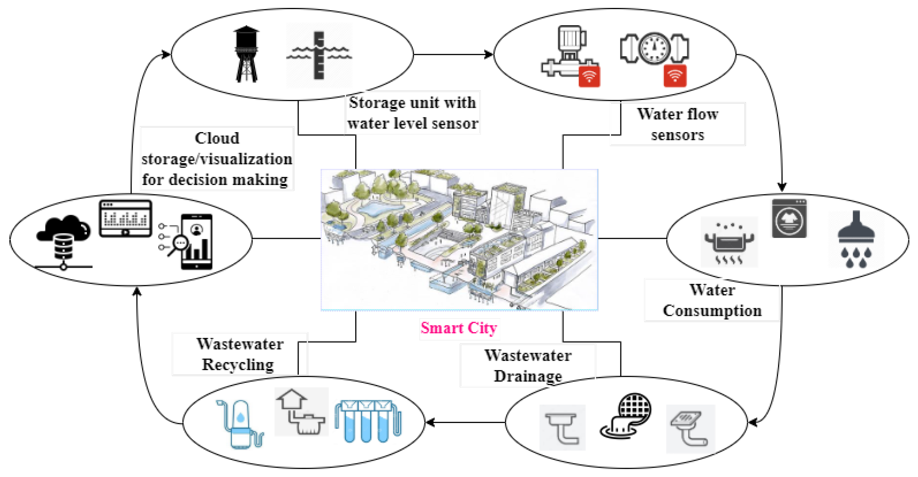
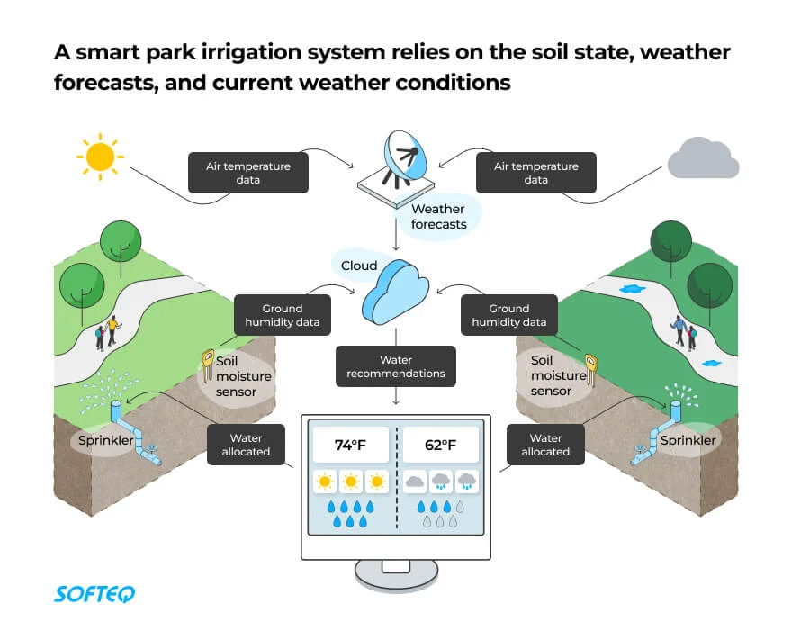

Main benefits :
- Boosted productivity of agricultural activities
- Prevented water waste
- More efficient use of water, fertilizer, and energy
- Automated activities

